PRACTICAL 4 : WRITING EMAIL

1. First login to your G-mail account and click on the Compose icon which is on the left side of the screen.

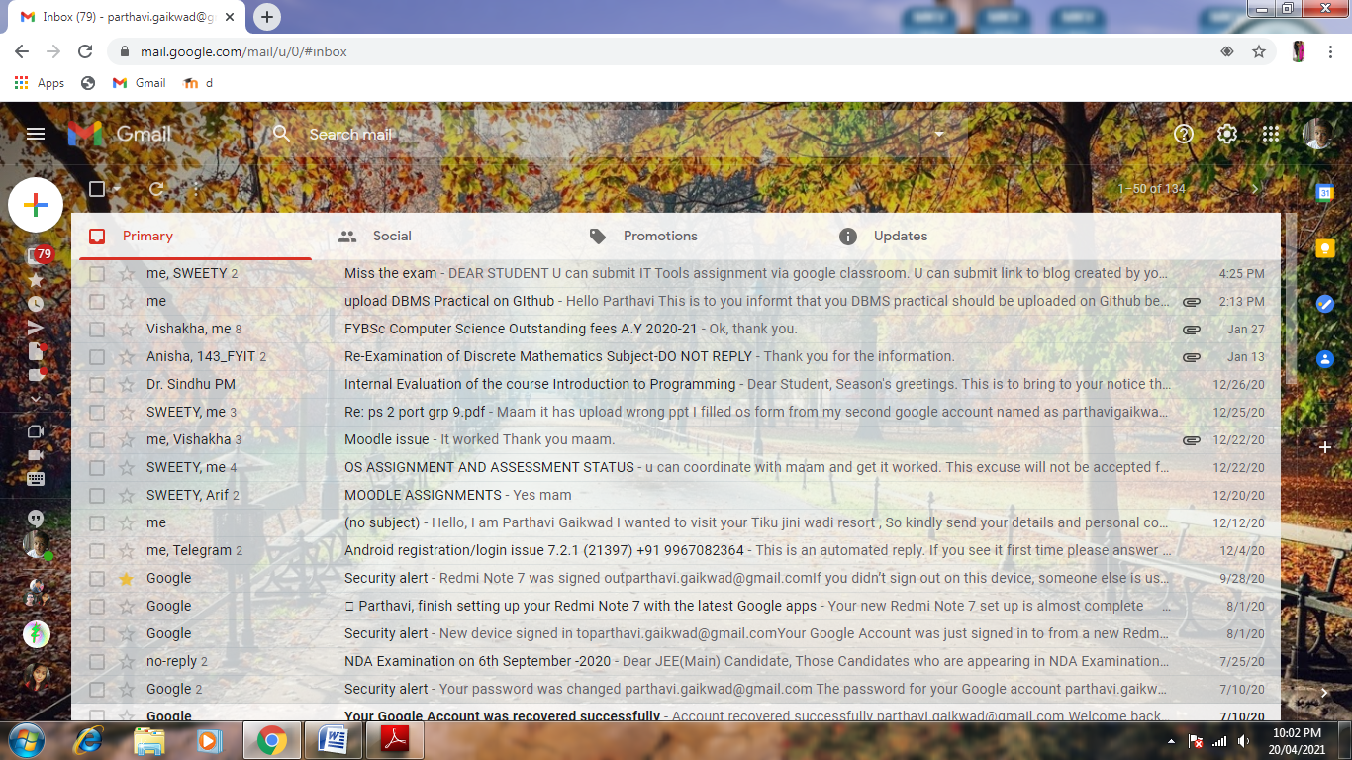

B. After clicking on Compose you have to fill the details of

➢ Sender’s Email address.

➢ Receiever’s email address.

➢ Subject [define the main cause for writing gmail to receiver].

➢ Body [here you have to write the detail about your topic].

➢ Signature to your mail.

➢ Attachment [here you can attach the document related to your topic].

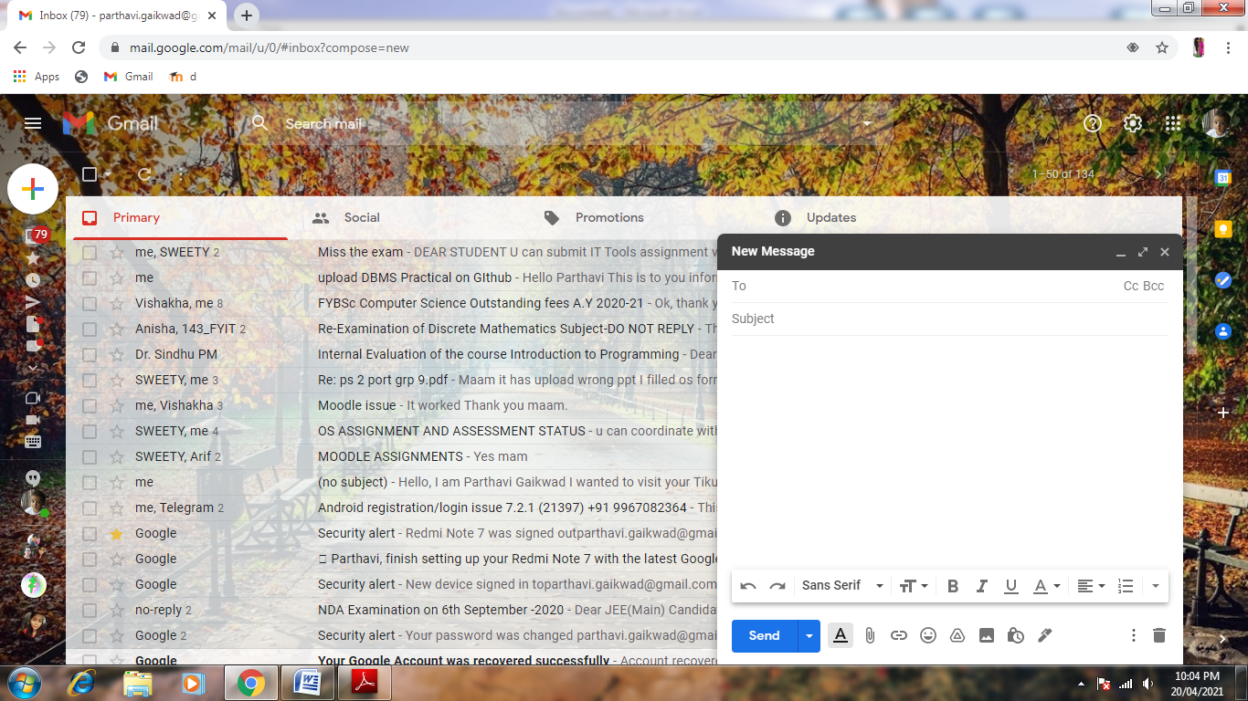

SENDER AND RECEVIER ADDREES

SUBJECT OF YOUR TOPIC

BODY DETAILS OF YOUR TOPIC

ATTACH DOCUMENT

ADD SIGNTURE

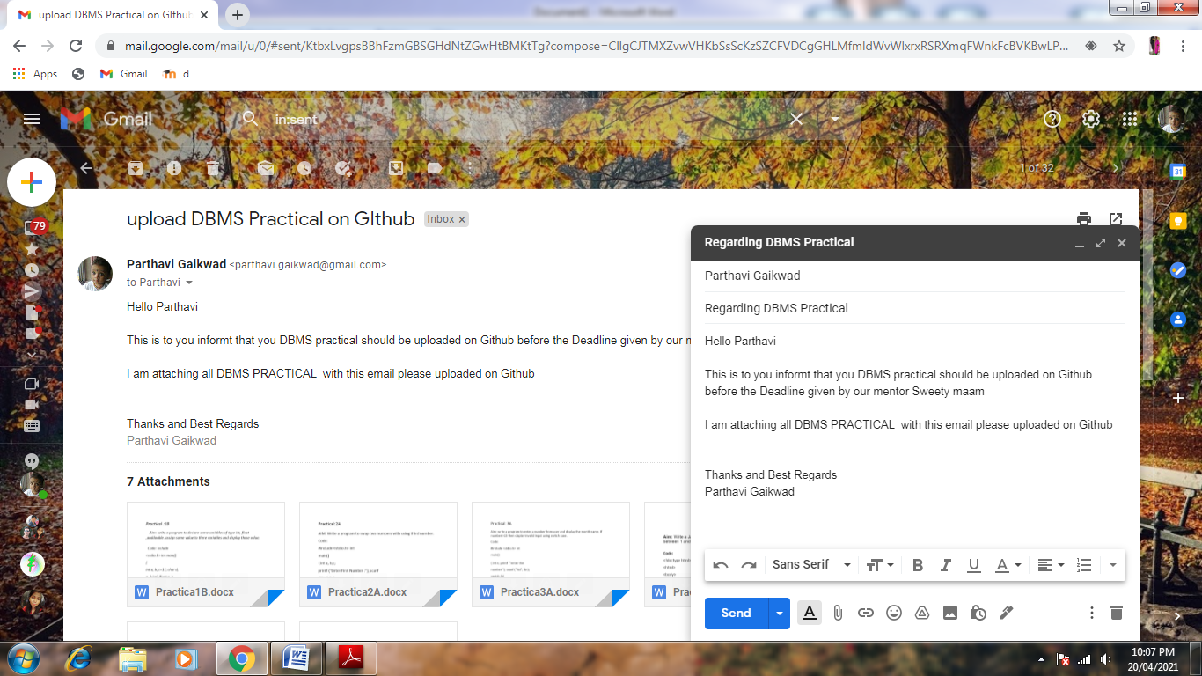

➢ To attach document click on attach icon and then select the file from your **system**

SELECT THE FILE

CLICK ON OPEN TO ATTACH

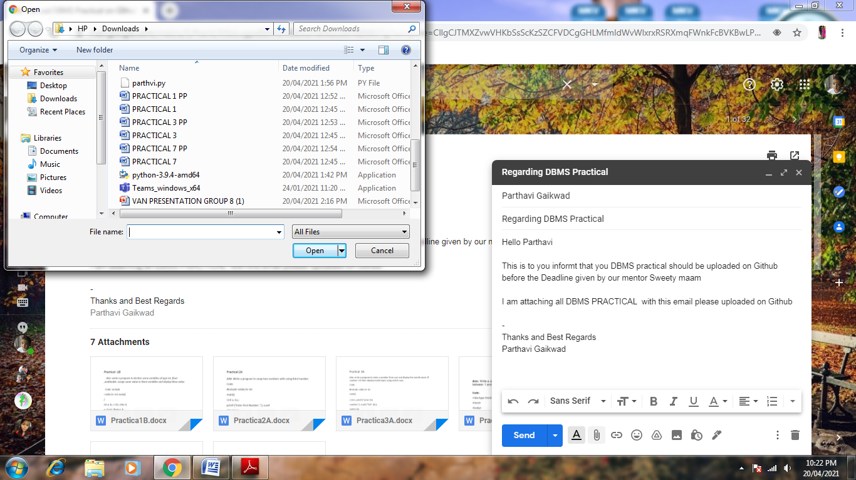

➢ After fill all details and attaching all document ,Click on sent icon to sent the email to the recipient.

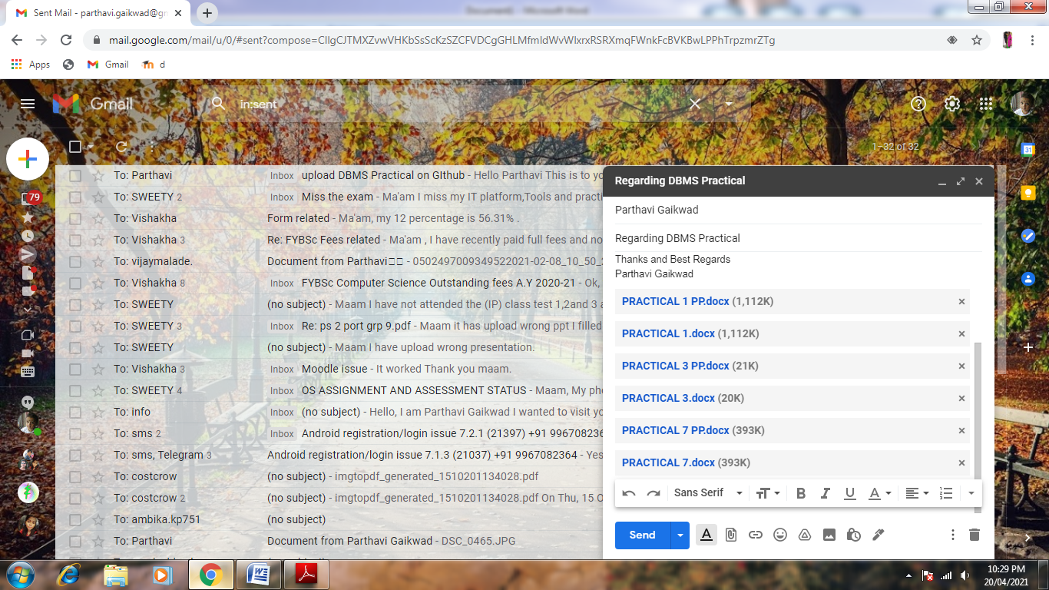

CLICK ON SEND ICON

➢ Click on Sent option to see your sent mail to recipient.

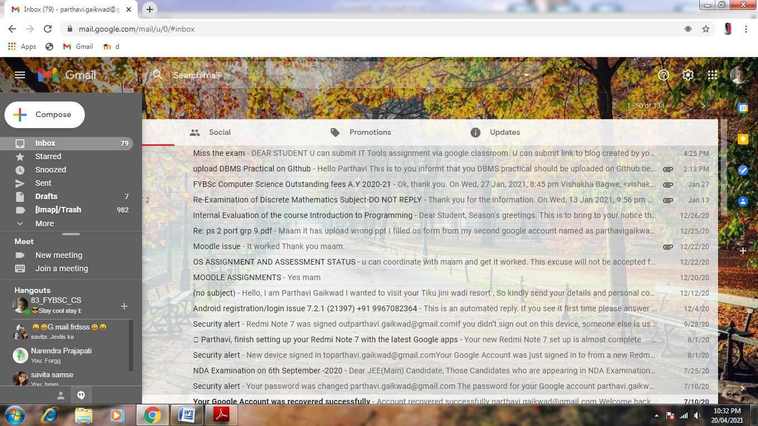

CLICK ON SENT

➢ Your email will be display in these way in your recipient mail box.

